Tiger Talk
  - August 12th, 2013
Helpful Links:
REL School Wiki: Go to this link to
download professional development
and school handouts.
http://lillardtigers.wikispaces.com/home
REL Library Website: Go to this link to
find library information and a
school calendar.
http://reltigers.weebly.com/
REL Library Catalogue: Go to this link to
locate school library books.
http://goo.gl/ShzVCI
Limitless Library: Library cards will
not be issued. Employee ID’s are now
used to have books sent to the school.
http://www.limitlesslibraries.org/

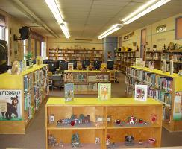

Thank you teachers for a good 1st week in the library; I appreciate your willingness to stay during orientation.

Let’s Talk

Q: Will the library be closed next week?
A: Yes! District Mandated Dibels testing begins. We will resume regular schedules the week of August 19th. 4th/5th grade will still come at designated time.

Q: When can my students begin checking out books?
A: Book check-out will begin the week of August 19th. Library Cards will be provided as soon as students have been uploaded from the district site.

Q: Didn’t you say to allow you a chance to establish your own classroom procedures teachers could leave?
A: Yes! But it is important for the teacher to understand the procedures and expectations in the library. So for the first two visits, teachers are asked to stay the entire time.
Beginning August 26th^{th}, you are welcome to stay the entire lesson but are most needed the last 10 minutes of class.
“Remember you can bring work to work on and just assist with check-out”

Q: Why are the library doors closed?
A: Due to Fire Marshall Codes the library doors are to stay closed Please feel free to come in anytime you are welcome!!!
“The ability to read becomes devalued when what one has learned to read adds nothing of importance to one's life.”
― Bruno Bettelheim

