Tiger Talk
  - August 26th, 2013
Helpful Links:
REL School Wiki: Go to this link to
download professional development
and school handouts.
http://lillardtigers.wikispaces.com/home
REL Library Website: Go to this link to
find library information and a
school calendar.
http://reltigers.weebly.com/
REL Library Catalogue: Go to this link to
locate school library books.
http://goo.gl/ShzVCI
MNPS Wiki : Go to this link to access the
Elementary Curriculum Framework
http://mnpsempoweringeducators.wikispaces.com/home
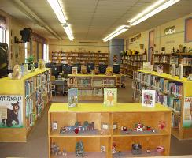

Let’s Talk

Q: What should I do for students who didn’t receive library cards?
A: Those students without cards can still checkout. I have to wait for Chancery to update and “talk” the library system before they can get an actual card.

Q: Can my students begin AR testing?
A: Absolutely! The first AR window begins Monday, August 26th. You will receive information in your box about the AR incentive program.

Q: Do you take teacher request about the library lesson of the week?
A: Yes and happily. If you have a specific skill (dictionary, reference, etc.) that you would like your students to learn let me know 2 days before your scheduled lesson.
As a reminder you no longer are required to stay with your students during their library visit; although you’re WELCOME. Please return the last 10 minutes of class to assist with check-out.

Q: Can you help me find resources to use in the classroom?
A: My pleasure. Please let me know at least 24 hours in advance if you need books, videos, and or websites on a specific topic. I am more than willing to pull these resources for you.
“We read to know that we are not alone.” C.S. Lewis

