Tiger Talk
  - September 23rd, 2013
Helpful Links:
REL School Wiki: Go to this link to
download professional development
and school handouts.
http://lillardtigers.wikispaces.com/home
REL Library Website: Go to this link to
find library information and a
school calendar.
http://reltigers.weebly.com/
REL Library Catalogue: Go to this link to
locate school library books.
http://goo.gl/ShzVCI
ReadWriteThink: Go to this
link to access a multitude of literacy
resources with lesson plans and rubrics.
http://readwritethink.org
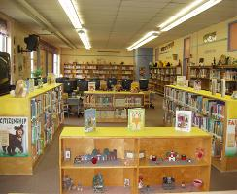

Let’s Talk

Q: Why are students allowed to check-out “one’ book that is not on their reading level?
A: It is my personal belief along with the American Library Association (ALA) that students should be provided an opportunity to read for personal growth. One of my responsibilities is to teach students to peruse personal and aesthetic growth.

Q: How can I check my students AR progress.
A: In the Reports Section of the AR program are a multitude of reports that show student progress. Please stop by if you need a quick tutorial on how to access reports.

Q: Why is it taking my students so long to come back from Open Check-out?
A: Open Check-out is in full swing. I have a large number of students coming each day and it is hard for me to tell who has stayed to long. Please discuss with your students how much time you are allowing them to select a book and return to class.
Regular scheduled library lessons will resume next week!
**See September Calendar from last week****

Q: Are you overwhelmed yet?
A: Yes! I believe transparency is vital to growth. After self-reflection I realized that it is very difficult to meet with each class and do a specials class daily. After Fall Break we will switch to having classes meet bi-weekly. More information to come.
“A capacity and taste for reading gives access to whatever has already been discovered by others”.
Abraham Lincoln

