Tiger Talk
  - September 2nd, 2013
Helpful Links:
REL School Wiki: Go to this link to
download professional development
and school handouts.
http://lillardtigers.wikispaces.com/home
REL Library Website: Go to this link to
find library information and a
school calendar.
http://reltigers.weebly.com/
REL Library Catalogue: Go to this link to
locate school library books.
http://goo.gl/ShzVCI
MNPS Wiki : Go to this link to access the
Elementary Curriculum Framework
http://mnpsempoweringeducators.wikispaces.com/home
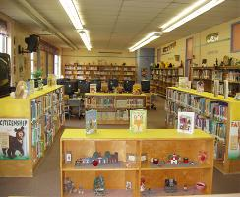

Let’s Talk

Q: I still haven’t received library cards for all students.
A: I am awaiting system updates so that I can print library cards for new students. Please send me an email of any students still needing a card.

Q: What do I do with “green volunteer forms”?
A: Please send any library volunteers to the library.

Q: Why is it taking my students so long to come back from Open Check-out?
A: Open Check-out is in full swing. I have a large number of students coming each day and it is hard for me to tell who has stayed to long. Please discuss with your students how much time you are allowing them to select a book and return to class.
As a reminder you no longer are required to stay with your students during their library visit; although you’re WELCOME. Please return the last 10 minutes of class to assist with check-out.

Q: Will the library be open during DEA testing.
A: Yes. The library will be available for afternoon check out beginning at 2:05 daily.
My Alma mater was books, a good library... I could spend the rest of my life reading, just satisfying my curiosity.
Malcolm X

