Tiger Talk
  - September 9th, 2013
Helpful Links:
REL School Wiki: Go to this link to
download professional development
and school handouts.
http://lillardtigers.wikispaces.com/home
REL Library Website: Go to this link to
find library information and a
school calendar.
http://reltigers.weebly.com/
REL Library Catalogue: Go to this link to
locate school library books.
http://goo.gl/ShzVCI
Reading is Fundamental : Go to this
link to access a multitude of literacy
resources.
http://rif.org/
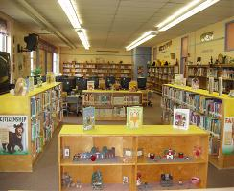

Let’s Talk

Q: Will we have library classes next week?
A: Unfortunately not! We are still in the midst of DEA testing. My goal is to come around during your regular scheduled library time and remind students about the AR incentive program and show how to access the “AR bookshelf”. Times will be in boxes on Monday!

Q: Can I check out class sets of book?
A: Absolutely! You are welcome to come and check out books under your name that your students can use during guided reading and/or independent reading time.

Q: Why is it taking my students so long to come back from Open Check-out?
A: Open Check-out is in full swing. I have a large number of students coming each day and it is hard for me to tell who has stayed to long. Please discuss with your students how much time you are allowing them to select a book and return to class.
As a reminder you no longer are required to stay with your students during their library visit; although you’re WELCOME. Please return the last 10 minutes of class to assist with check-out.

Q: Will the library be open during DEA testing.
A: Yes. The library will be available for afternoon check out beginning at 2:05 daily.
“A reader lives a thousand lives before he dies, said Jojen. The man who never reads lives only one.”
George R.R. Martin

